**ST. XAVIER’S COLLEGE**

**(Affiliated to Tribhuvan University)**

**Maitighar, Kathmandu**



**COMPUTER NETWORK LAB REPORT #04**

**SUBMITTED BY:**

Pradeep Dahal

017BSCIT029

2nd year/ 4th sem

**SUBMITTED TO:**

|  |  |
| --- | --- |
|  | Signature |
| Mr. Sanjay Kumar Yadav  (Lecturer) |  |
| Department of Computer Science | |

**OBJECTIVE: CONFIGURE CISCO ROUTER PASSWORD, SETTING CONSOLE PASSWORD, ENABLE PASSWORD AND TELNET PASSWORD**

**REQUIREMENTS**

1. Cisco Packet Tracer
2. Router
3. Switch
4. End Devices
5. Console Cables
6. Straight through cables

**THEORY:**

**ROUTER:**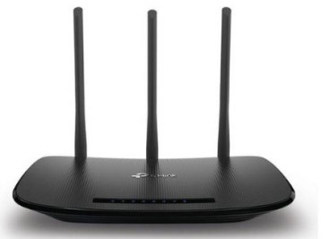

A router is a physical or virtual appliance that passes information between two or more packet-switched computer networks -- analyzing a given data packet's destination IP address, calculating the best way for it to reach that destination and then forwarding it accordingly.

A router is a common type of gateway -- positioned where two or more networks meet, including at each point of presence on the internet. Hundreds of routers might forward a single packet as it moves from one network to the next on the way to its final destination.

Passwords are used to restrict access to a CISCO router. Passwords can be given to the virtual terminal lines and the console line.

Why console password is required?

Console password is useful on a network on which multiple people have to access to the router. The persons who are not authorized, can't access the router. Thus it prevents unauthorized person from accessing the router.

Why virtual terminal password is required?

Virtual terminal password refers to telnet password. Through telnet, you can access the router and can change anything. So, it's really important to protect the use of telnet by giving a strong password.

Why enable password is required?

Enable password is required to restrict the access of privileged EXEC mode.

**PROCEDURE:**

STEP 1: First of all, we configure the router as we did in LAB 3.

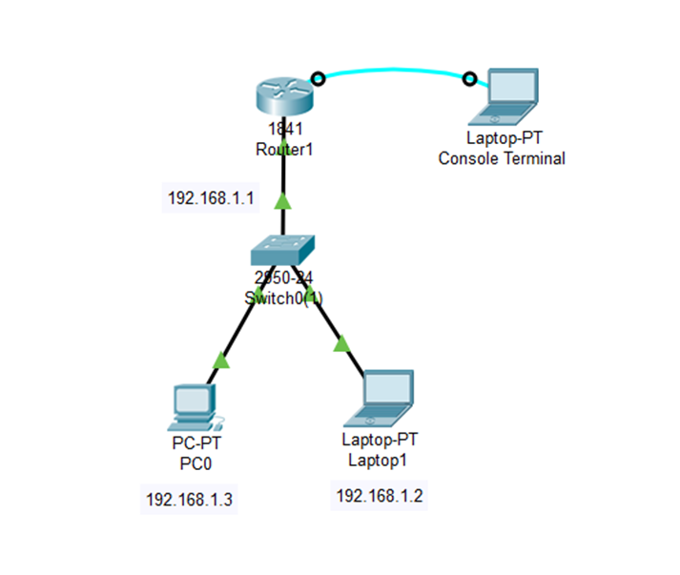

STEP 2: Configuring console password of a CISCO routers:

1. Enter global configuration mode of the CISCO router.
2. Put the command line console 0 to the router.
3. Provide the password by using password command. For example, if you want to put password "cisco" then the command will be password cisco.
4. At last, put the command login.

Commands for configuring console password

Router>enable

Router#config t

Enter configuration commands, one per line. End with CNTL/Z.

Router(config)#line console 0

Router(config-line)#password cisco

Router(config-line)#login

Router(config-line)#

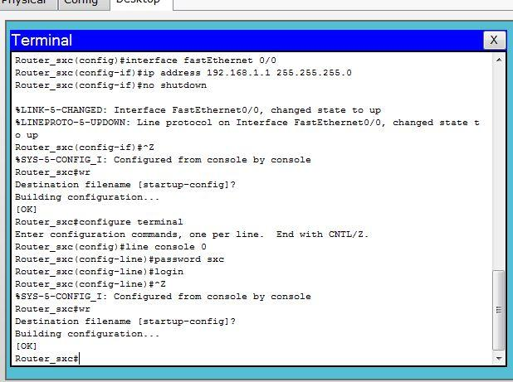

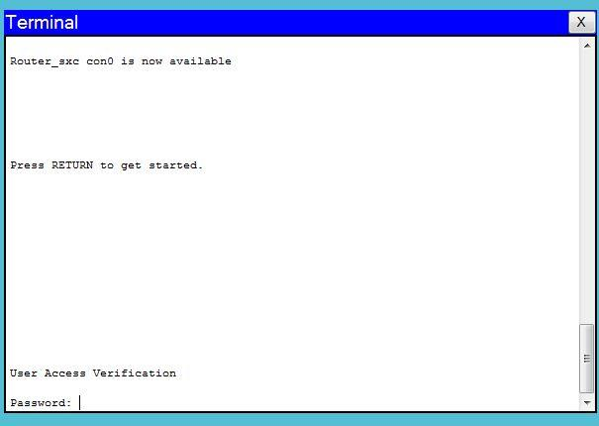

STEP 3: Configuring enable password of a CISCO router:

From the global configuration mode, use the command enable password to restrict access to privileged EXEC mode. However, this password is visible in the routers configuration file. To encrypt the password, enable secret command is required. By using enable secret command the password is encrypted and can't be readable to a human.

Commands for configuring enable password

Router>enable

Router#configure terminal

Enter configuration commands, one per line. End with CNTL/Z.

Router(config)#enable password cisco

Router(config)#

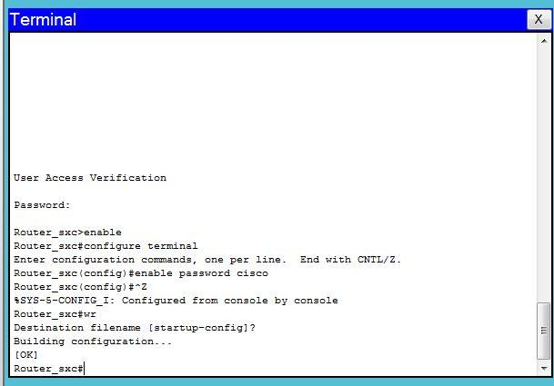

STEP 4: The password assigned could be seen when typed “show running-config” so the password was made secret remaining encrypted.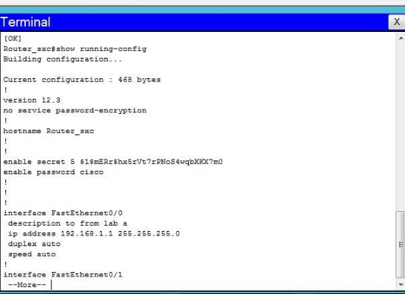

Perform password encryption:

Router>enable

Router#configure terminal

Router(config)#enable secret cisco

Router(config)#

STEP 5: To access the router through a remote device “telnet” was encoded in the Command Prompt. As no access was granted the router could not be accessed.

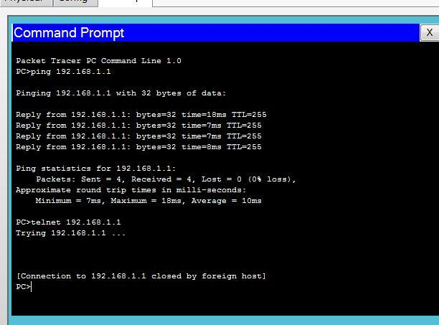

STEP 6: Configuring virtual terminal password of a CISCO router (TELENET password):

Different hardware has different no of vty lines defined. Cisco has the range 0 to 4 vty lines. It means it has 5 vty lines. Set the password of vty lines by the following steps:

1. Enter global configuration mode of the CISCO router.
2. Put the command line vty 0 4 to the router.
3. Provide the password by using password command. For example, if you want to put password "cisco" then the command will be password cisco.
4. At last, put the command login.

Commands for configuring virtual terminal password

Router>enable

Router#configure terminal

Router(config)#line vty 0 4

Router(config-line)#password cisco

Router(config-line)#login

Router(config-line)#

To enable remote login from command prompt, virtual terminal(vty) must be enabled. So, for this we assigned telnet password as ‘test’.

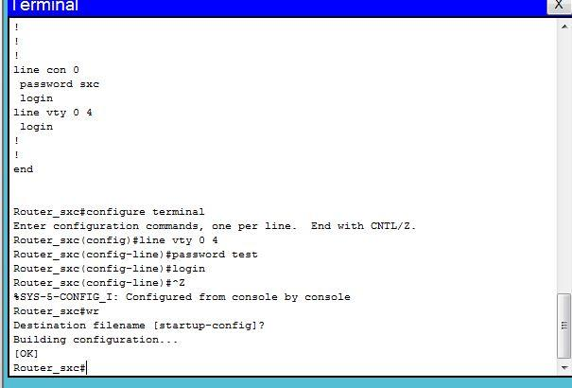

Now, through a remote device the router could be accessed by entering the assigned password.

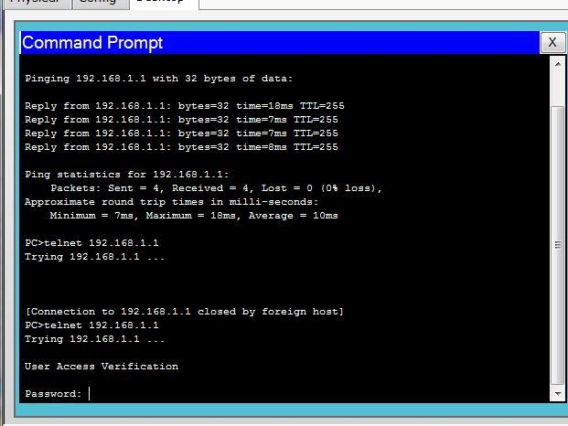

**CONCLUSION:**

Hence, in this way, we configured cisco router password.